How to login/create an account to access Nottinghamshire’s County Counicl Online Forms

- Whether you already have an account or you are using the service for the first time, you can click the relevant option in the top right hand corner or the middle of the your screen

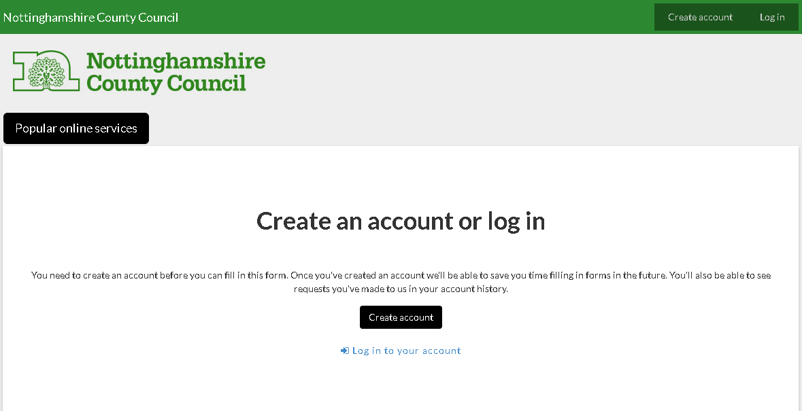

Creating your new account:
- Once you have clicked on the Create account option above, you will need to follow the instructions on the screen.
  - Enter your email address
  - Create a password
  - Click
- Email verification is required so you will be sent an email with a link to click to activate your account.
- Once your account has been set up you will see
- Click ‘log in’
Logging into an existing account:
- Enter your email address & password then click Log in

Accessing the forms:

- Once logged in you can access the form you require in the alphabetical list by clicking ‘view all our online services’.

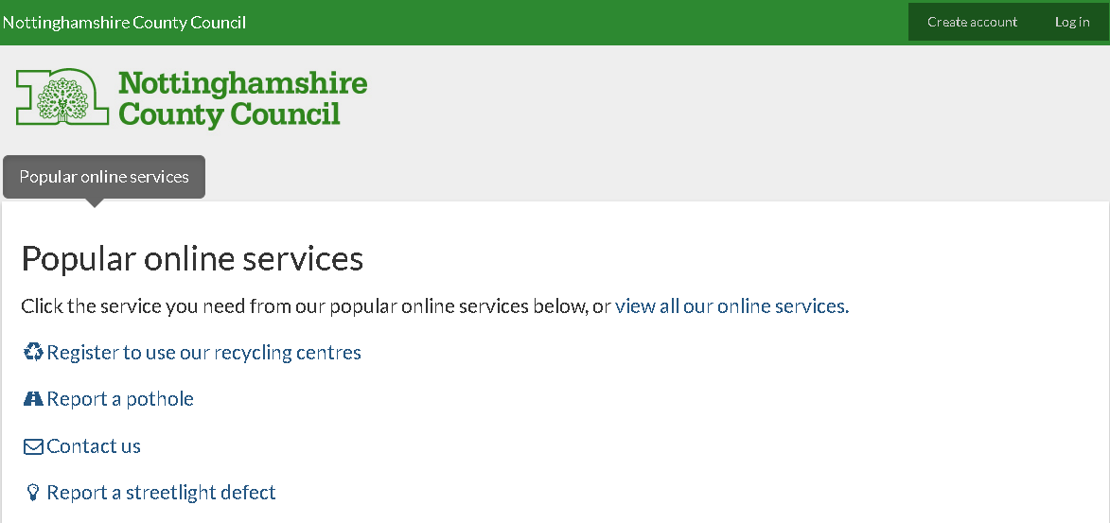

- All Pension forms can be found under ‘P’.
